# Practical2_Dictionary
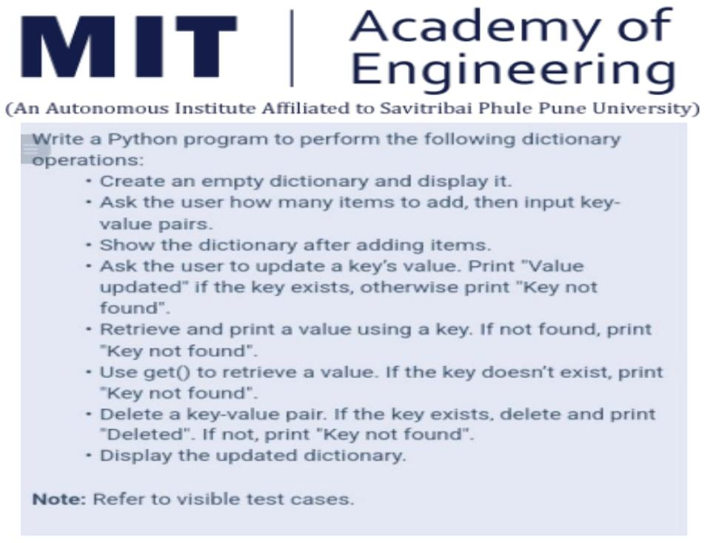

Code:

#Dictionary Operations

data = {}
print("Empty dictionary : ", data)

#Add
n = int(input("How many items do you want to add?"))
for i in range(n):
key = input("Enter key: ")
value = input("Enter value: ")
data[key] = value
print("Dictionary after adding items: ", data)

#Update
update_key = input("Enter key to update: ")
if update_key in data:
new_value = input("Enter new value: ")
data[update_key] = new_value
print("Value updated")
else:
print("Key not found")

#Retrieve using normal method
search_key = input("Enter key to retrieve value: ")
if search_key in data:
print("Value:", data[search_key])
else:
print("Key not found")

#Retrieve using get()
get_key = input("Enter key to retrieve using get(): ")
value = data.get(get_key)
if value is not None:
print("Value:", value)
else:
print("Key not found")

#Delete
delete_key = input("Enter key to delete:")
if delete_key in data:
del data[delete_key]
print("Deleted")
else:
print("Key not found")

#Display
print("Updated dictionary: ", data)

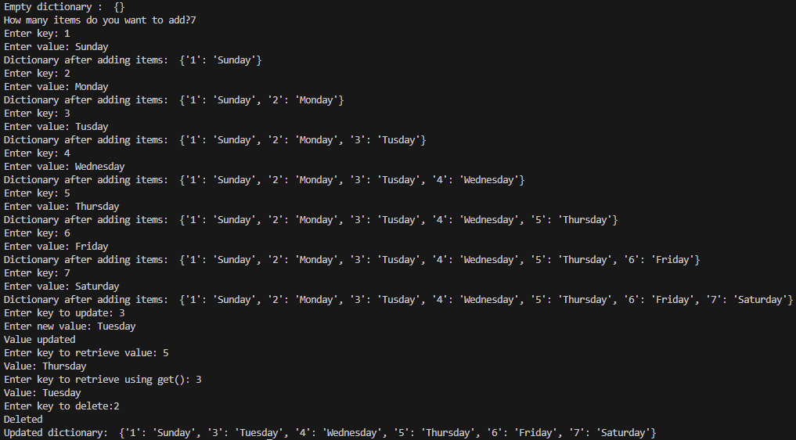
Output:

